NPI Community Data Analysis

Mwaura Patrick

3/5/2021

### Names of the variables

1. Name of IK holder/THP herbalist–Name
2. Location–Location
3. County.–County
4. Town /village.–Village
5. Contact Telephone /email.–Tel
6. email.–Email
7. Type of herbal product(s)(liquid,powder,paste,cream etc.–Product_Nature
8. Condition / disease managed–Condition
9. Local community of origin&county–Origin_County
10. Education of TPH/ IK Holder–Education_level
11. Years of practice–Experience_Years
12. Is the herbal product / concotion in the market? –Market_Availability
13. Nature of immune booster–ImmuneBooster_Nature
14. Explain the process of formulating this product –Explanation
15. List the symptoms of COVID-19 FLU/common cold/asthma (upper respiratory disease)–Covid_19_Symptoms
16. How it is administered.–Administration
17. Additional notes.–Notes
18. TK holder/THP is clear on diagnosis/ cause of disease.–Diagnosis_Clarity_1
19. comments–Comments
20. TK provider has provided specific regimen for immune booster /FLU/COVID -19–ImmuneBooster_Specific_Regimen_2
21. will TK provider willing to provide specific immune booster / FLU/COVID -19–ImmuneBooster_Provision_3
22. IK provider has patient follow up mechanism.–Patient_Followup_4
23. Provider has records system for patients.–Patient_Records_5
24. Provider has packaging mechanism /action plans.–Product_Packaging_6
25. Has product been properly labeled–Product_Labeling_7
26. What is the stability of the product?How long can you store product–Storage_Length_8
27. Provider / IK holder /THP has known continuous source of medicinal plants–Consistent_Source_9
28. Provider/IK holder /THP is a member to an association/ society/Group–Association_Membership_10
29. Provider is aware of intellectual property (IP) processes (registered with relevant government 32. departments)–IP_Process_Awareness_11
30. Is TK Holder aware of where and how they can protect their knowledge–Knowledge_Protection_Awareness_12
31. Provider has started the process/ patented the products.–Product_Patent_13
32. Date.–Date

### 1. Characterize the IK Holders

THPS SCETION 1 Background information AGE, GENDER, EDUCATION, RESIDENCE

Section 3 Product 8, 9 & 10

Gender and Age were not captured in the questionnaire

| **Proportion with Respect to level of Education** | | |
| --- | --- | --- |
| **Education Level** | **n** | **percent** |
| **K.C.S.E** | **61** | **25.21%** |
| **K.C.P.E** | **35** | **14.46%** |
| **Informal Education** | **29** | **11.98%** |
| **College** | **22** | **9.09%** |
| **Class 7** | **15** | **6.20%** |
| **Others** | **13** | **5.37%** |
| **Diploma** | **11** | **4.55%** |
| **Bachelor’s Degree** | **10** | **4.13%** |
| **Form 2** | **10** | **4.13%** |
| **Class 5** | **6** | **2.48%** |
| **K.J.S.E** | **6** | **2.48%** |
| **Vocation** | **6** | **2.48%** |
| **Form 3** | **5** | **2.07%** |
| **Class 3** | **4** | **1.65%** |
| **Class 4** | **4** | **1.65%** |
| **Form 6** | **2** | **0.83%** |
| **Class 6** | **1** | **0.41%** |
| **Form 5** | **1** | **0.41%** |
| **PhD- Doctorate** | **1** | **0.41%** |

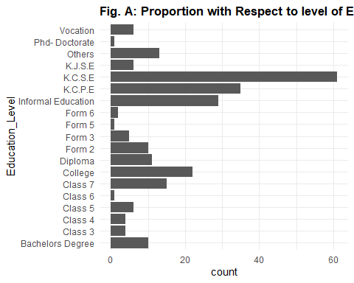

| Average Length of Storage in Months by Level of Education | |
| --- | --- |
| **Education Level** | **Months** |
| Class 4 | 12 |
| K.J.S.E | 9 |
| K.C.P.E | 9 |
| College | 6 |
| Diploma | 5 |
| K.C.S.E | 5 |
| Bachelor’s Degree | 2 |
| Form 2 | 2 |
| Class 7 | 1 |
| Others | 0 |
| Informal Education | 0 |
| Class 3 | 0 |
| Class 5 | 0 |
| Class 6 | 0 |
| Form 3 | 0 |
| Form 5 | 0 |
| Form 6 | 0 |
| PhD- Doctorate | 0 |
| Vocation | 0 |

| Most Experienced by level of Education(Average) | |
| --- | --- |
| **Education Level** | **Experience Years** |
| Class 6 | 46 |
| Class 4 | 27 |
| Class 7 | 26 |
| Bachelor’s Degree | 22 |
| Form 2 | 22 |
| K.J.S.E | 21 |
| Class 5 | 20 |
| Form 5 | 20 |
| Informal Education | 19 |
| Others | 19 |
| K.C.P.E | 18 |
| PhD- Doctorate | 18 |
| Form 3 | 17 |
| Vocation | 16 |
| Class 3 | 15 |
| Diploma | 15 |
| K.C.S.E | 15 |
| College | 12 |
| Form 6 | 9 |

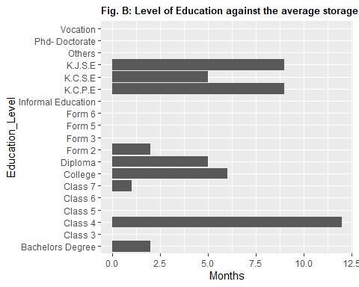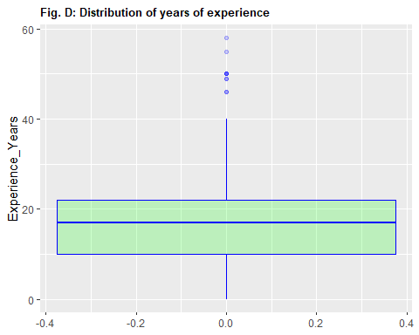

| **Membership Association by Level of Education** | | | |
| --- | --- | --- | --- |
| **Education Level** | **No** | **Yes** | **Total** |
| **Bachelor’s Degree** | **0.00% (0)** | **5.24% (10)** | **4.13% (10)** |
| **Class 3** | **1.96% (1)** | **1.57% (3)** | **1.65% (4)** |
| **Class 4** | **0.00% (0)** | **2.09% (4)** | **1.65% (4)** |
| **Class 5** | **1.96% (1)** | **2.62% (5)** | **2.48% (6)** |
| **Class 6** | **0.00% (0)** | **0.52% (1)** | **0.41% (1)** |
| **Class 7** | **1.96% (1)** | **7.33% (14)** | **6.20% (15)** |
| **College** | **11.76% (6)** | **8.38% (16)** | **9.09% (22)** |
| **Diploma** | **9.80% (5)** | **3.14% (6)** | **4.55% (11)** |
| **Form 2** | **3.92% (2)** | **4.19% (8)** | **4.13% (10)** |
| **Form 3** | **1.96% (1)** | **2.09% (4)** | **2.07% (5)** |
| **Form 5** | **1.96% (1)** | **0.00% (0)** | **0.41% (1)** |
| **Form 6** | **0.00% (0)** | **1.05% (2)** | **0.83% (2)** |
| **Informal Education** | **5.88% (3)** | **13.61% (26)** | **11.98% (29)** |
| **K.C.P.E** | **17.65% (9)** | **13.61% (26)** | **14.46% (35)** |
| **K.C.S.E** | **31.37% (16)** | **23.56% (45)** | **25.21% (61)** |
| **K.J.S.E** | **5.88% (3)** | **1.57% (3)** | **2.48% (6)** |
| **Others** | **1.96% (1)** | **6.28% (12)** | **5.37% (13)** |
| **PhD- Doctorate** | **0.00% (0)** | **0.52% (1)** | **0.41% (1)** |
| **Vocation** | **1.96% (1)** | **2.62% (5)** | **2.48% (6)** |
| **Total** | **100.00% (51)** | **100.00% (191)** | **100.00% (242)** |

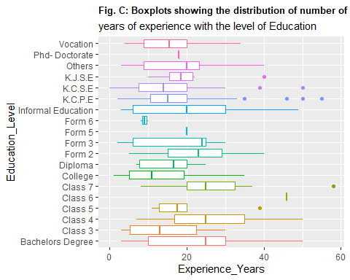

| **Count by County of Practice** | | |
| --- | --- | --- |
| **County** | **n** | **percent** |
| **Bungoma** | **12** | **5.9%** |
| **Busia** | **12** | **5.9%** |
| **Embu** | **15** | **7.4%** |
| **Homabay** | **4** | **2.0%** |
| **Kakamega** | **14** | **6.9%** |
| **Kilifi** | **1** | **0.5%** |
| **Kirinyaga** | **8** | **3.9%** |
| **Kisumu** | **9** | **4.4%** |
| **Koelia** | **1** | **0.5%** |
| **Kwale** | **24** | **11.8%** |
| **Laikipia** | **9** | **4.4%** |
| **Lamu** | **4** | **2.0%** |
| **Meru** | **10** | **4.9%** |
| **Migori** | **7** | **3.4%** |
| **Mombasa** | **10** | **4.9%** |
| **Muranga** | **5** | **2.5%** |
| **Nyandarua** | **11** | **5.4%** |
| **Nyeri** | **8** | **3.9%** |
| **Siaya** | **6** | **3.0%** |
| **Taita Taveta** | **11** | **5.4%** |
| **Tana River** | **10** | **4.9%** |
| **Tharaka Nithi** | **6** | **3.0%** |
| **Vihiga** | **6** | **3.0%** |

| **Count by County of Origin** | | |
| --- | --- | --- |
| **Origin County** | **n** | **percent** |
| **Bungoma** | **12** | **5.0%** |
| **Busia** | **12** | **5.0%** |
| **Embu** | **19** | **7.9%** |
| **Homa Bay** | **9** | **3.8%** |
| **Kakamega** | **17** | **7.1%** |
| **Kiambu** | **1** | **0.4%** |
| **Kilifi** | **2** | **0.8%** |
| **Kirinyaga** | **10** | **4.2%** |
| **Kisumu** | **9** | **3.8%** |
| **kwale** | **1** | **0.4%** |
| **Kwale** | **24** | **10.0%** |
| **Kwale County** | **4** | **1.7%** |
| **Laikipia** | **5** | **2.1%** |
| **Lamu** | **3** | **1.3%** |
| **Meru** | **12** | **5.0%** |
| **Migori** | **8** | **3.3%** |
| **Mombasa** | **7** | **2.9%** |
| **Murang'a** | **6** | **2.5%** |
| **Nyandarua** | **14** | **5.9%** |
| **Nyeri** | **12** | **5.0%** |
| **Siaya** | **10** | **4.2%** |
| **Taita Taveta** | **10** | **4.2%** |
| **Tana River** | **11** | **4.6%** |
| **Tharaka-Nithi** | **6** | **2.5%** |
| **Vihiga** | **15** | **6.3%** |

### 2. Characterize the products

Type form or evaluate their products

Section 1: Background -Type of product, -Is it in markets

| Nature of the Product | | |
| --- | --- | --- |
| **Product Nature** | **n** | **percent** |
| Cream | 62 | 15.5% |
| Liquid | 160 | 40.0% |
| Powder | 178 | 44.5% |

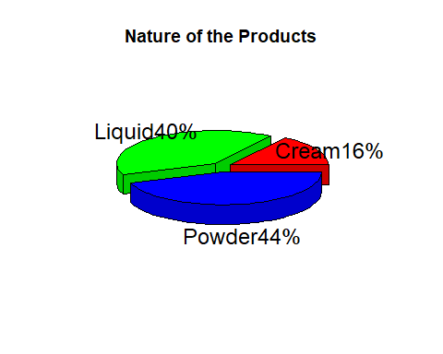

| Product availability in the Market | | |
| --- | --- | --- |
| **Market Availability** | **n** | **percent** |
| No | 88 | 37.3% |
| Yes | 148 | 62.7% |

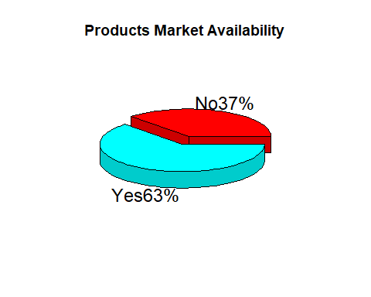

### Section 2: Processing (though poorly answered) ### Section 3: Product: 6, 7, and 9 -Packaging -labeling -Sourcing sustainability/conservation

| Product Packaging, Labeling, Sourcing | | | | | | |
| --- | --- | --- | --- | --- | --- | --- |
|  | **Product Packaging** | | **Product Labeling** | | **Consistent Source** | |
| **Response** | **Count** | **Percent** | **Count** | **Percent** | **Count** | **Percent** |
| No | 72 | 29.8% | 98 | 40.5% | 20 | 8.3% |
| Yes | 170 | 70.2% | 144 | 59.5% | 222 | 91.7% |

### 3. Describe the healthcare system section 3: Product; 1, 2 3&4

-Diagnosis -Regimen -Follow-up

| Clarity in Diagnosing a Condition | | |
| --- | --- | --- |
| **Diagnosis Clarity** | **n** | **percent** |
| No | 19 | 7.9% |
| Yes | 223 | 92.1% |
| Regimen for Boosting Immunity | | |
| **Immune booster Specific Regimen** | **n** | **percent** |
| No | 77 | 31.8% |
| Yes | 165 | 68.2% |
| Patient Follow-up | | |
| **Patient Follow-up** | **n** | **percent** |
| No | 33 | 13.6% |
| Yes | 209 | 86.4% |